[Input Company Name]
[Logo Image Here]

[Today’s Date]

[Input Agency Name]
[Input: Attention To: Buyer Name]
[Input Agency Address]

[Input Re: Solicitation Number + Solicitation Name]

[Dear: Input Buyer Name or Agency Name}
[A few sentences about the company, as an example, date when you came into business, size of organization, certifications your business has attained, size of team, successful projects you’ve done in the past]
[A few sentences about the team, as an example, background on team or team members, i.e. types of experience, years of experience]
[A few sentences about past experiences that relate to this solicitation or are transferrable to this solicitation, as an example how your organization has provided this good/service to others successfully, how you have satisfied customers in this area the agency is requesting]
[A close to your cover letter, as an example a few sentences thanking for the opportunity to respond and communicate, an

[Your Name]
[Title]
[Address]

[Table Of Contents Page]
This is a sample table of contents– the agency you are responding to may have a different list of items they require & specific order or checklist of items they want you to include as a part of your bid response. Please read through the agencies instructions that are included in their advertisement to ensure you follow their instructions.
 | Page
Cost form/pricing sheet | 2
Experience and References | 3
Required Signed Forms (may be forms the agency wants you to sign as a part of your bid)  - Addendum Acknowledgement  - W9 | 4-5
Appendices (may be forms the agency wants a copy of)  - Copy of Small Business Certification  - Copy of Bid bond  - Copy of Insurance | 6-8
Additional Reference Items (items you may want to include that are not required as a part of the proposal | 9

[Cost Form/Pricing Sheet]
This is a sample pricing sheet; the agency may have provided one for you to fill out as part of their requirements. Please completely read through the bid instructions the agency provided to ensure that you follow their required forms

Item | Description | Quantity | Unit Cost | Total Cost
[Name of item] | [Description of product/service] | [number, unit of measure] | [price per unit of measure] | [total cost of amount service/supply]
Example: Landscaping | Example: Weeding, mowing, mulch | Example: 1500 square feet | Example: $4.00 per foot | Example: $6,000
Example: Promotional items | Example: ball point pens with agency logo | Example: 20,000 pens | Example: $1.20 per pen | Example: $24,000
 |  |  | Total Bid | [Total cost of all items priced]

[References Page]
This is a sample reference page; the agency may have provided one for you to fill out as part of their requirements. Please completely read through the bid instructions the agency provided to ensure that you follow their required forms.

Reference #1
Entity Name | [Input name of company/agency]
Scope of Work | [Input brief description of project/service/supply provided to entity]
Entity Address | [Input address]
City, State, Zip | [Input City, State, Zip]
Point of Contact | [Input reference first name, last name]
Phone Number | [Input reference phone number]
Email | [Input reference email address]

Reference #2
Entity Name | [Input name of company/agency]
Scope of Work | [Input brief description of project/service/supply provided to entity]
Entity Address | [Input address]
City, State, Zip | [Input City, State, Zip]
Point of Contact | [Input reference first name, last name]
Phone Number | [Input reference phone number]
Email | [Input reference email address]

Reference #3
Entity Name | [Input name of company/agency]
Scope of Work | [Input brief description of project/service/supply provided to entity]
Entity Address | [Input address]
City, State, Zip | [Input City, State, Zip]
Point of Contact | [Input reference first name, last name]
Phone Number | [Input reference phone number]
Email | [Input reference email address]

Required Signed Forms: Addendum Acknowledgment
This is a sample addendum acknowledgement form; the agency may have provided one for you to fill out and sign as part of their requirements. Please completely read through the bid instructions the agency provided to ensure that you follow their required forms
(Sample below of what an addendum acknowledgement form might look like)

ADDENDUM ACKNOWLEDGEMENT Painting of New School Gym Bid Submission Check List: Confirm by placing a check mark in the space provided that as the Bidder the information listed below has been reviewed and complied with in the submission of a response to this Bid.

- _____ Addenda acknowledgement.
(B) _____ Bid document has been signed by authorized Bidder official.
(C) _____ Bid package has been properly labeled per the instructions.
(D) _____ Bid Response Package Forms

The signature below certifies the Bid response complies with the requirements of this IFB and that the above items A through C have been verified as complete.

Authorized Signature ______________________________________

Required Signed Forms: W9
This is a sample W9 form, the agency may have provided one for you to fill out and sign as part of their requirements. Please completely read through the bid instructions the agency provided to ensure that you follow their required forms
(Sample below of what your W9 might look like)
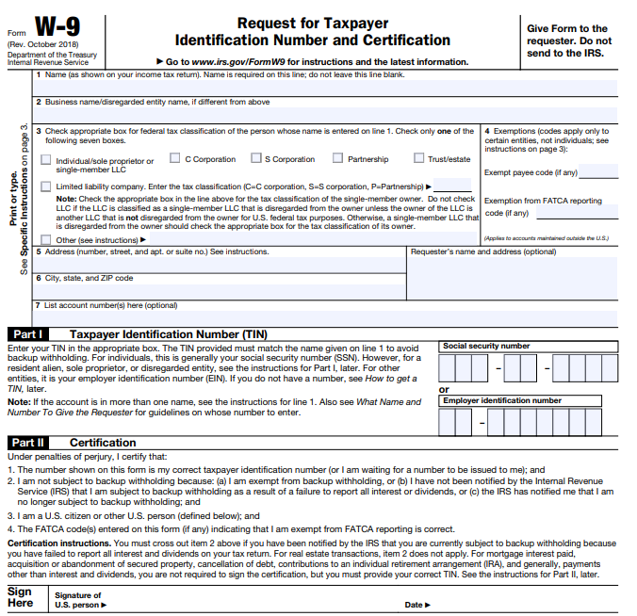

Appendices: Small Business Certification Copy

Appendices: Copy of Small Business Enterprise Certificate
The is a sample documentation below and may not be what the agency requires. Please completely read through the bid instructions the agency provided to ensure that you follow their required forms/documents.
(Sample of what a small business certificate may look like)

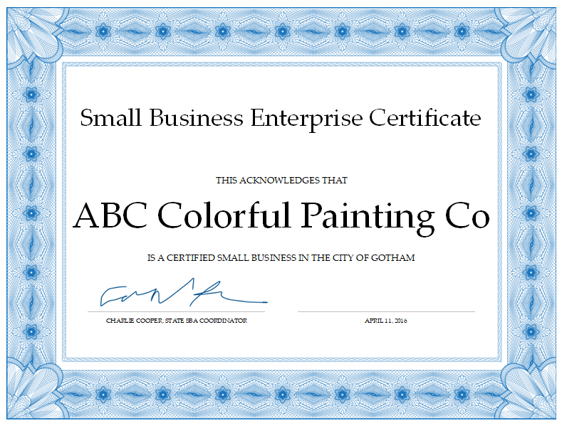

Appendices: Copy of Bid Bond
The is a sample documentation below and may not be what the agency requires. Please completely read through the bid instructions the agency provided to ensure that you follow their required forms/documents.
(Sample of what a bid bond may look like)

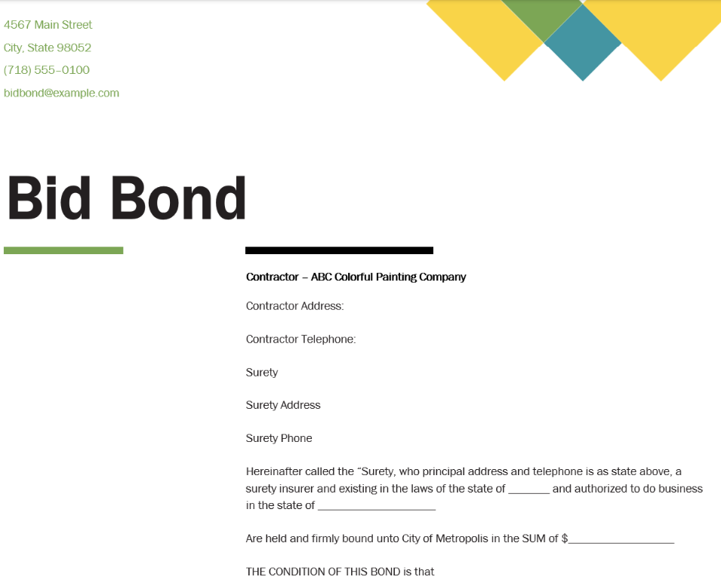

Appendices: Copy of Insurance
The is a sample documentation below and may not be what the agency requires. Please completely read through the bid instructions the agency provided to ensure that you follow their required forms/documents.
(Sample of what a evidence of insurance requested may look like)
