ABC Colorful Painting Company

February 12, 2022

Agency Name: City of Metropolis
Attn: Lois Lane
Agency Address: 9000 Daily Planet Drive, City of Metropolis, 32323
Re: Solicitation Number 5432-ABCD-2022 “Painting of New School Gym” “Solicitation Name”

Dear Buyer
ABC Colorful Painting Co. has been in business since 2005 completing over 150 residential and commercial painting jobs in the City of Metropolis. During our 17 years in business our team has painted structures small as1200 square feet to our largest project at 32,500 square feet. These structures have been made of metal, wood, composite, and brick. We have a history of completing our contracts on time and on budget and have provided a list of references as a part of our bid proposal. We have completed numerous projects of your size and scope.
Our 12 painters have a combined 132 years of painting experience. We are a certified small minority owned business and have been certified since 2006. Four of the painters on staff have completed government projects prior to working at ABC Colorful Painting Co.
During the past 18 months we’ve completed the painting of 3 similar sized commercial building to the one you need painted, and our customers are willing to speak to you about the excellent quality of work we did.
We have completed all the required items as a part of the bid response, and we look forward to the possibility of partnering with the City of Metropolis for this very important job.

Bruce Wayne
Manager of Painting Specialist
444 Clover Drive Gotham City, New York

Table Of Contents
 | Page
Cost form/pricing sheet | 3
Experience and References | 4
Required Signed Forms (may be forms the agency wants you to sign as a part of your bid)  - Addendum Acknowledgement  - W9 | 5-6
Appendices (may be forms the agency wants a copy of)  - Copy of Small Business Certification  - Copy of Bid bond  - Copy of Insurance | 7-9
Additional Reference Items (items you may want to include that are not required as a part of the proposal | 10

Cost Form/Pricing Sheet

Item | Description | Quantity | Unit Cost | Total Cost
Gutters | Painting 1500 feet of gutters powder blue | 1,500 feet | $1.50 ft | $2,250
Walls | Painting 20,000 sq ft of walls krypton green | 20,000 sq ft | $3.50 | $70,000
Moldings | Painting 2,500 feet of molding canary yellow | 2,500 feet | $3.00 | $7,500
 |  |  | Total Bid | $79,750

References Page

Reference #1
Entity Name | Sunny Township
Scope of Work | Painted 12,000 square feet of conference hall
Entity Address | 3902 Sunny Town Drive
City, State, Zip | Sunny, Arizona 00304
Point of Contact | Leonard Luther
Phone Number | 555-594-5959
Email | Leonard.Luther@sunnytownship.com

Reference #2
Entity Name | Glitter School District
Scope of Work | Painted 14,000 square feet storage building
Entity Address | 1304 Question Avenue
City, State, Zip | Greenville, Virginia 30311
Point of Contact | Jim Riddler
Phone Number | 333-304-4959
Email | j.riddler@glitterschools.com

Reference #3
Entity Name | Homerville Parks and Rec’s Department
Scope of Work | Painted tennis courts and basketball court surfaces
Entity Address | First Parkway 32
City, State, Zip | Felton, Texas 23232
Point of Contact | Kelly Kingston
Phone Number | 020-220-3929
Email | k.kingston@hprdept.org

Required Signed Forms: Addendum Acknowledgment
(Sample below of what an addendum acknowledgement form might look like)

ADDENDUM ACKNOWLEDGEMENT Painting of New School Gym Bid Submission Check List: Confirm by placing a check mark in the space provided that as the Bidder the information listed below has been reviewed and complied with in the submission of a response to this Bid.

- _____ Addenda acknowledgement.
(B) _____ Bid document has been signed by authorized Bidder official.
(C) _____ Bid package has been properly labeled per the instructions.
(D) _____ Bid Response Package Forms

The signature below certifies the Bid response complies with the requirements of this IFB and that the above items A through C have been verified as complete.

Authorized Signature ______________________________________

Required Signed Forms: Addendum Acknowledgment
(Sample below of what your W9 may look like)

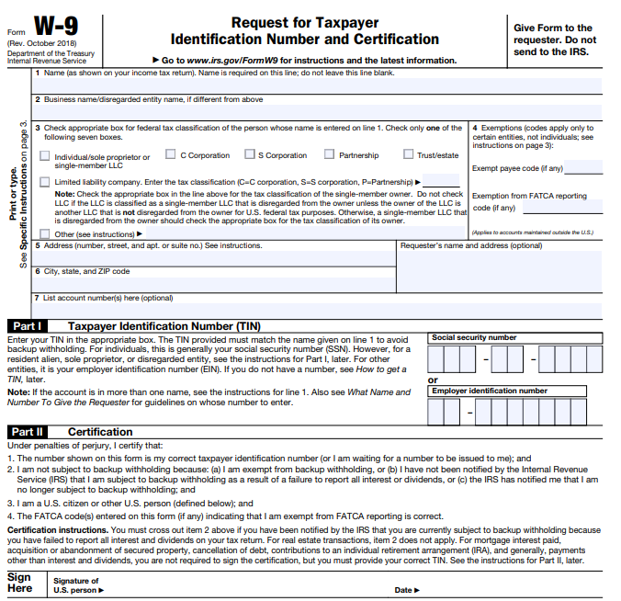

Appendices: Small Business Certification Copy
(Sample below of what your certification might look like)

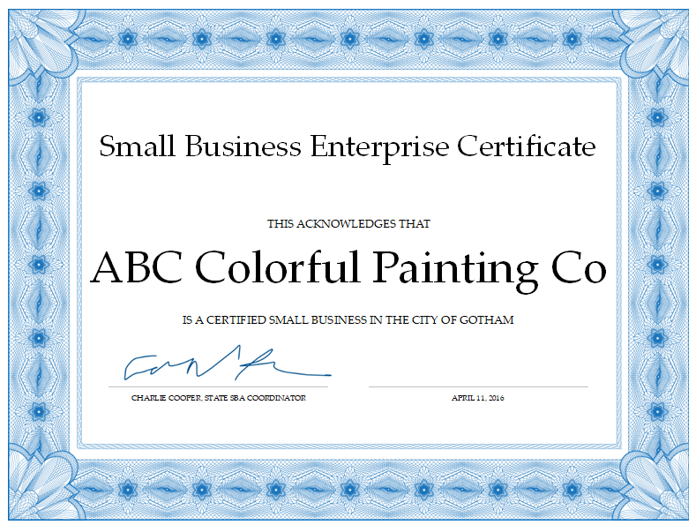

Appendices: Copy of Bid Bond
(Sample below of what a bid bond might look like)

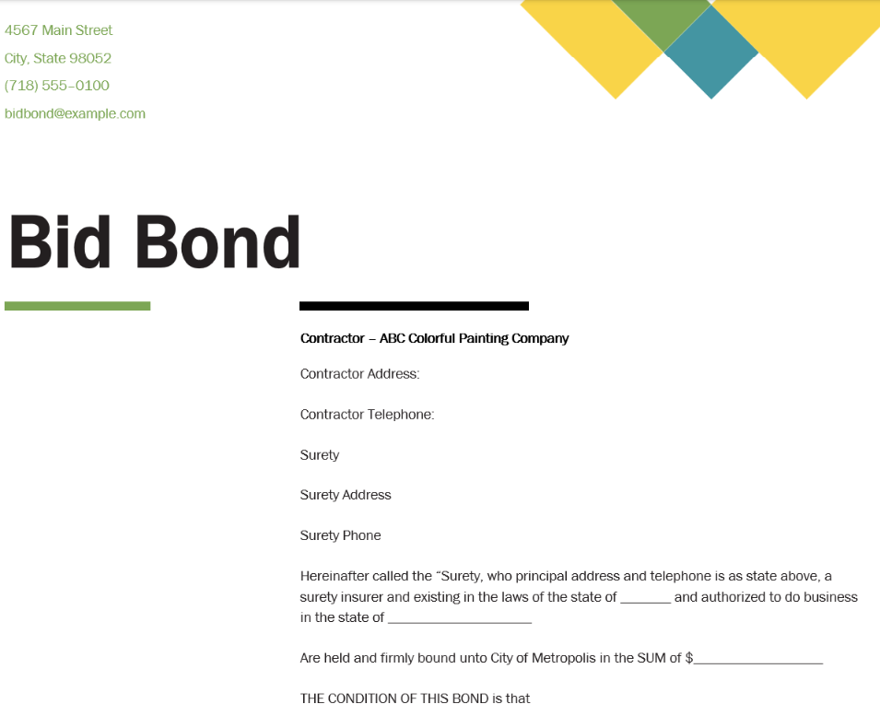

Appendices: Copy of Insurance
(Sample below of what a copy of insurance might look like)

